Seminar Sheet 3
For this seminar we will consider how we can use vector and matrix multiplication to orient, and generate procedural animation in our games. In this weeks lecture we have considered how objects can form a hierarchy. How they can have global and local rotation/translation and scale. This seminar sheet will be based on rotations/translations, transformation hierarchies and animation curves. Procedural animation is used in various parts of games. From a door opening, to a button being clicked, or the way in which a camera might pan around the action. We may want to consider how we can move actors, meshes, or components based on information from the world or from user/designer input.

Problem 1.
An orrery is a mechanical device that shows the movement of planets and astral bodies. I want you to construct a solar system like scene, where the planets and moons are rotating and orbiting a sun. Consider the axis of rotation, the origin, and the point of rotation of each body.
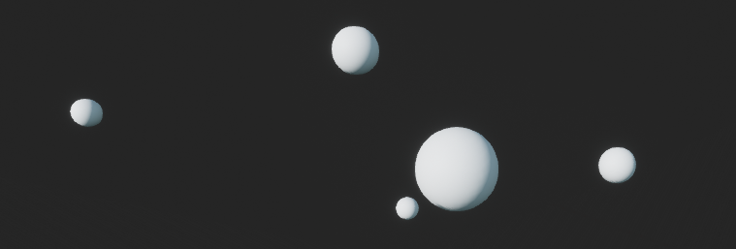
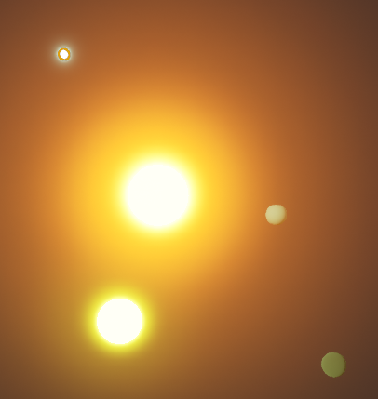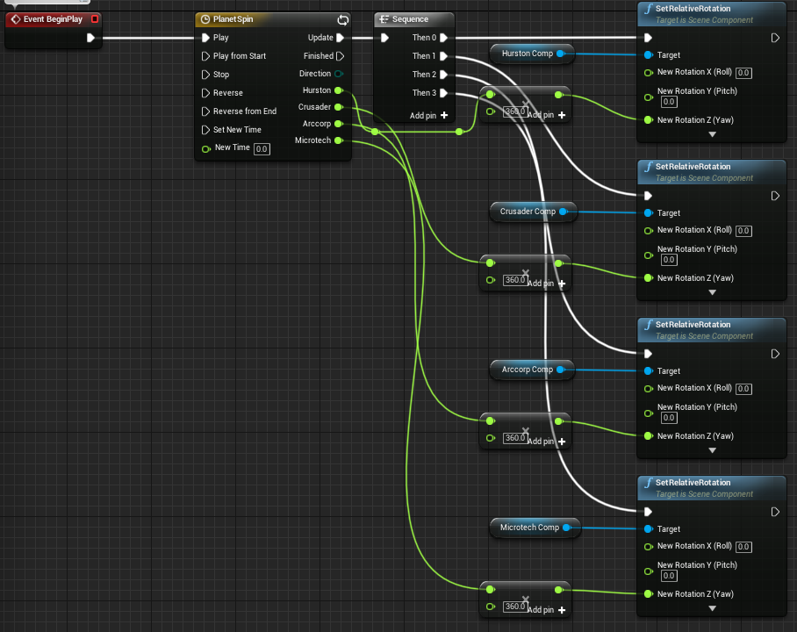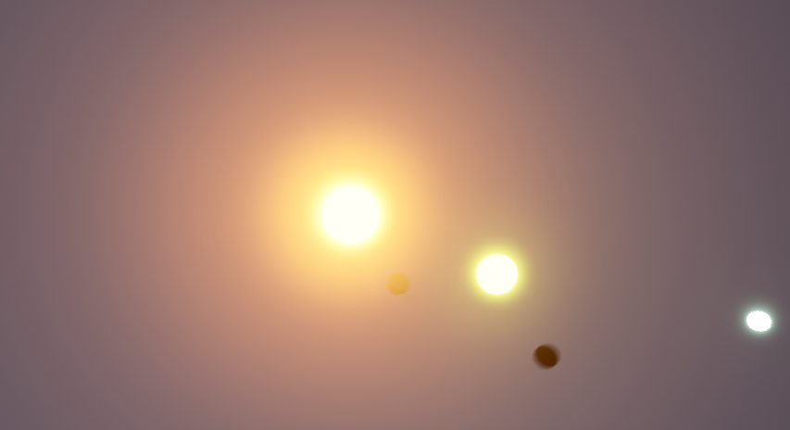
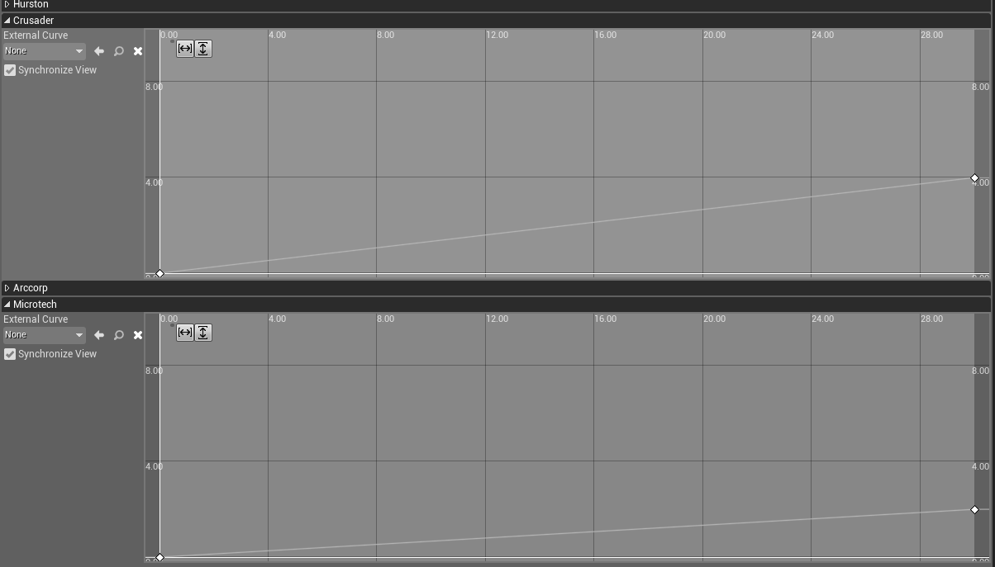

Problem 2.
In lots of games moving platforms are omnipresent. Creating a simple moving platform system that has a start and an end point, translate and move the platform between each point. Provide parameters to a designer that allow them to specify travel time, and widgets to place the start and end in the editor.
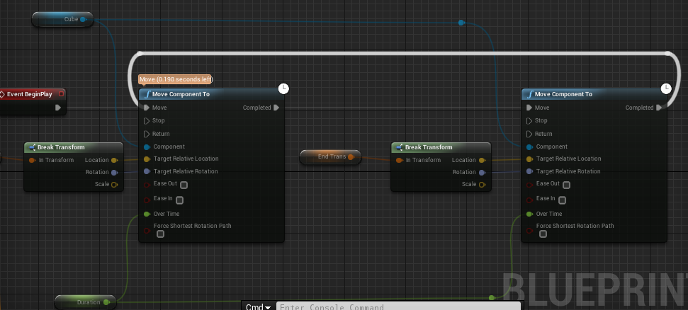
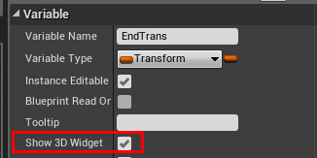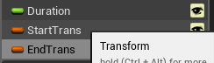
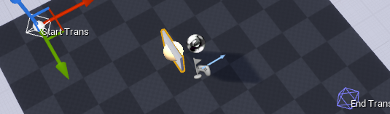
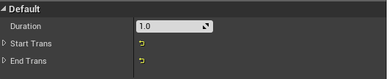
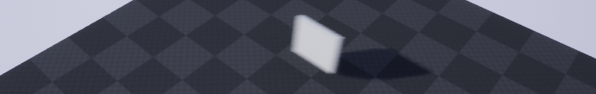
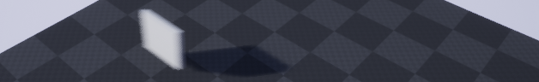

Problem 3.
In ﬁrst year you will have considered easing functions, and ways to animate that are more aesthetically pleasing than a simple linear interpolation. Pick an easing function, implement it in blueprint or C++ and use this to animate an object of your choice. (this could be the platform from the previous problem or other objects you have made in previous seminar sheets). Additionally: Experiment with the curve editor and can you replicate the same functionality with a generic curve a designer can input. Instead of some hand written code/blueprint.
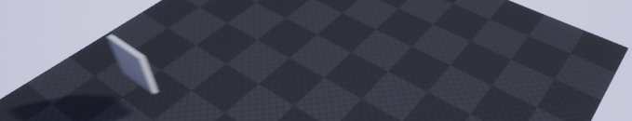
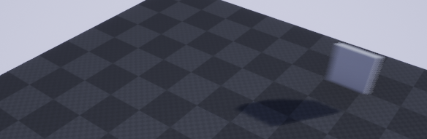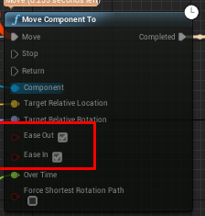

Problem 4 (Extension).
Building on problem 2. Research and consider how you could translate/move a platform between two points in a non linear fashion. How do you orient the platform to face the direction of a curve? Can you make this a toggle for a designer

